1. Git clone: <https://github.com/AlexeyAB/darknet.git>
2. 查看说明文档：

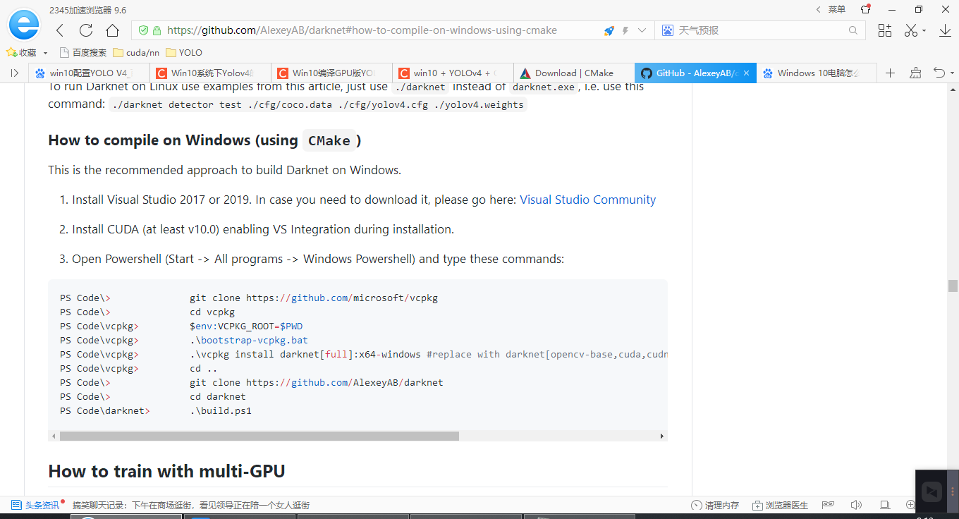

1. 查看需求：
   1. Visual studio 2017或2019，本机版本2019; 满足
   2. Install CUDA (at least v10.0), 本机10.1; 满足；同时cudnn也满足；
   3. 安装requirements:
      1. 安装 OpenCV, 3.4.12
      2. 安装Cmake 3.19.1: add path to all users: cmake安装成功（直接下载，一路下一步，然后增加一个添加到路径，默认地址）

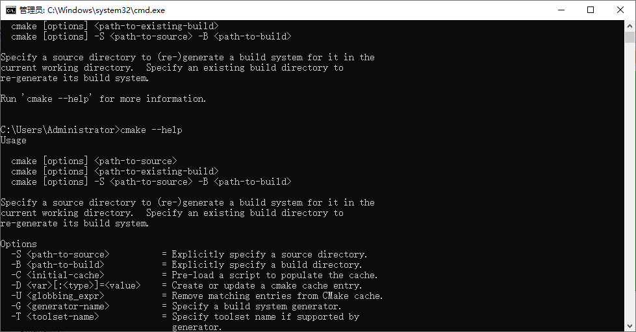

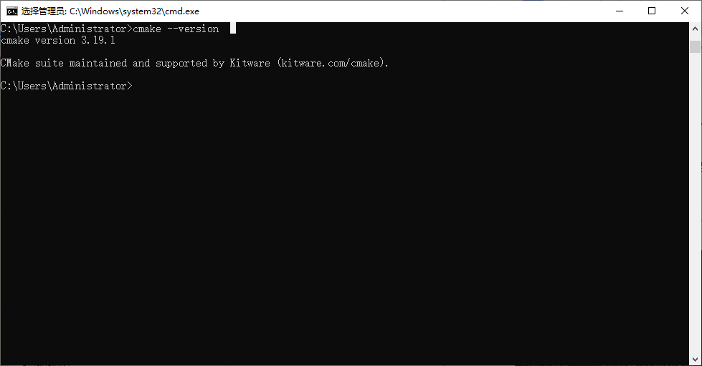

* 1. 尝试使用Cmake编译
     1. 使用GPU加快检测速度。则需要对Makefile文件进行修改。

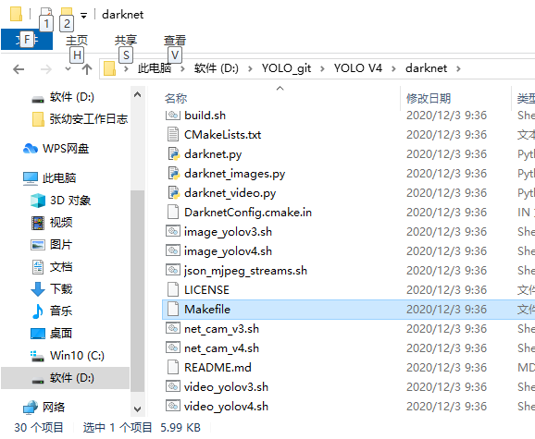

* + 1. 将Makefile文件用记事本打开，更改GPU=1 CUDNN=1 CUDNN_HALF=1 OPENCV=1

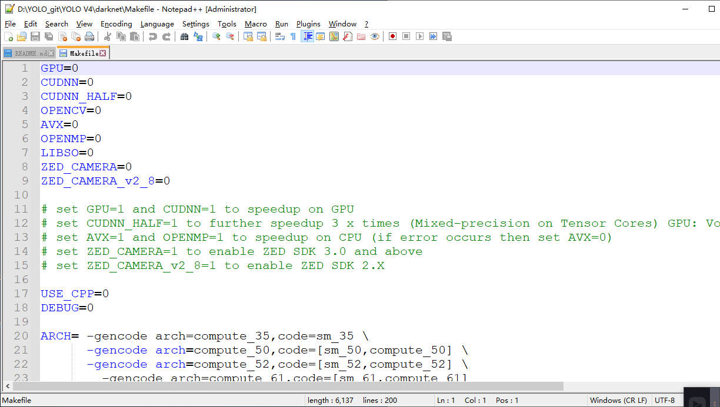

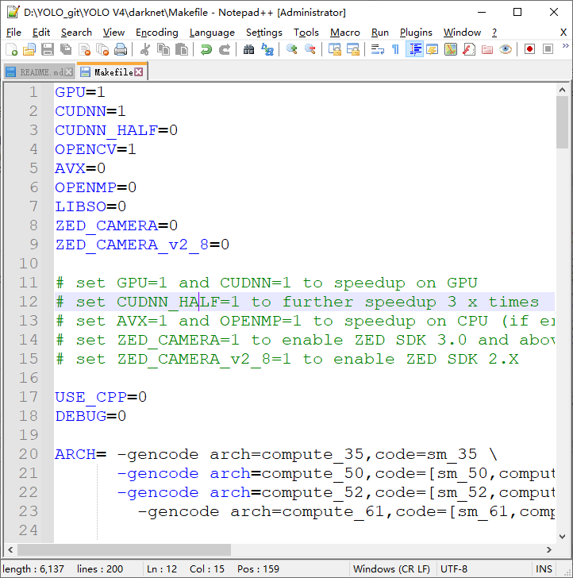

1. 打开cmake.exe, 输入如下地址。（为git的地址）

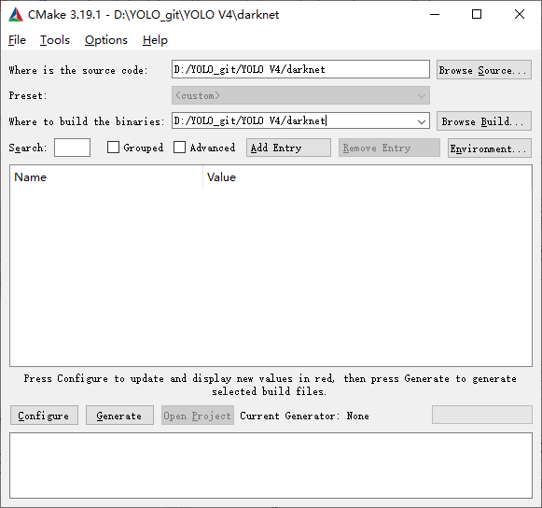

1. 按configure

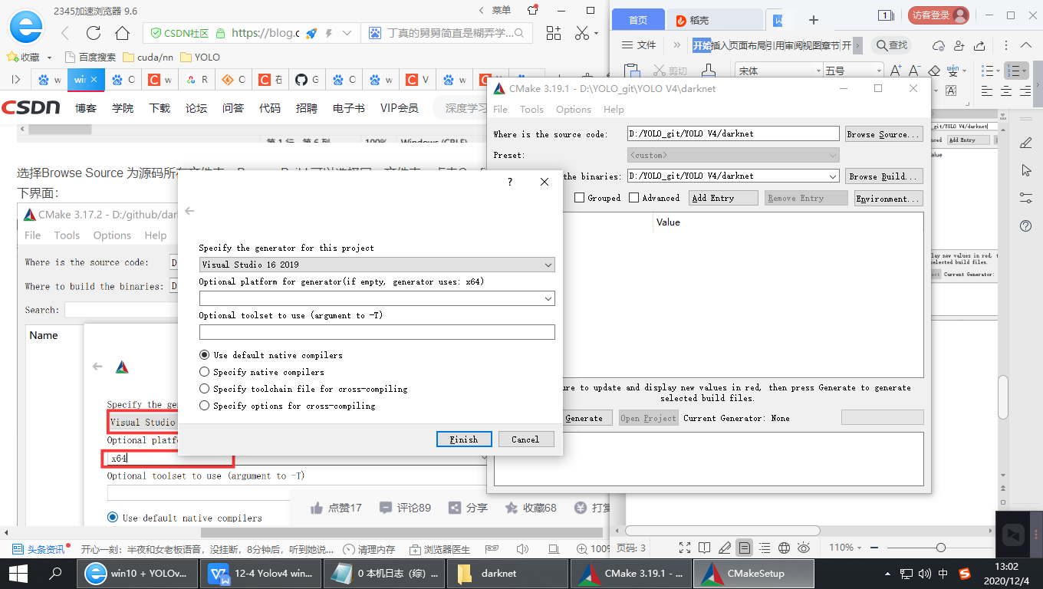

1. 输入如下：

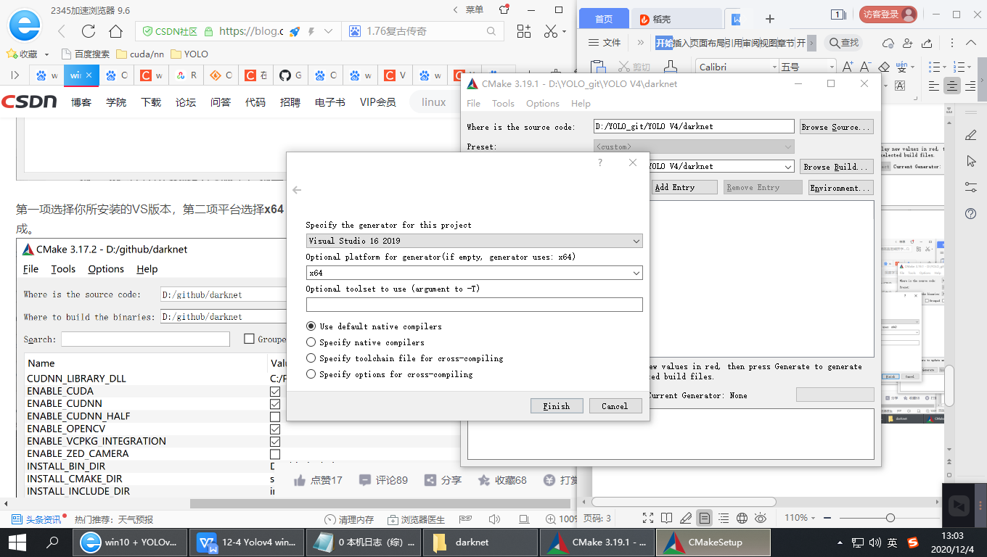

1. 报错Configuring incomplete, errors occurred!猜想是vs2019中没下载全，因此打开vs2019,下载了所有c++的东西，应该是有一个编译的。删掉CMakeFiles所有文件。

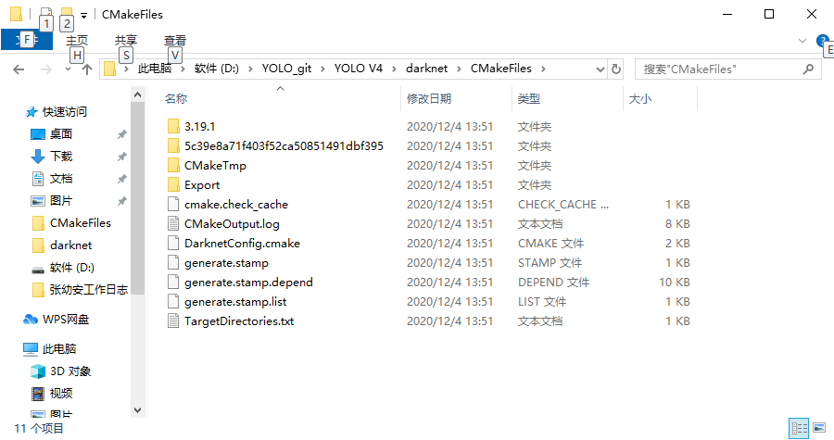

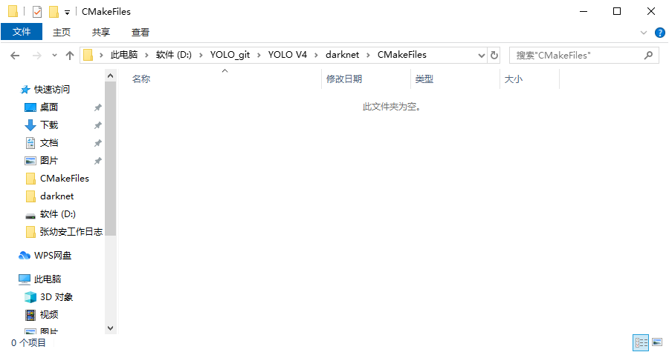

1. 然后configure,能编译成功了。但无法找到cuda.准备再调整一下。

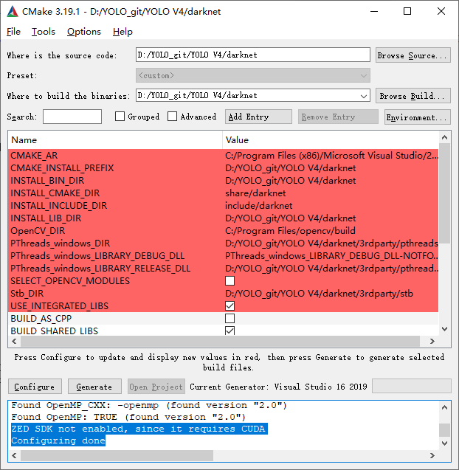

1. 具体结果：

Selecting Windows SDK version 10.0.18362.0 to target Windows 10.0.17763.

The C compiler identification is MSVC 19.28.29334.0

The CXX compiler identification is MSVC 19.28.29334.0

Detecting C compiler ABI info

Detecting C compiler ABI info - done

Check for working C compiler: C:/Program Files (x86)/Microsoft Visual Studio/2019/Community/VC/Tools/MSVC/14.28.29333/bin/Hostx64/x64/cl.exe - skipped

Detecting C compile features

Detecting C compile features - done

Detecting CXX compiler ABI info

Detecting CXX compiler ABI info - done

Check for working CXX compiler: C:/Program Files (x86)/Microsoft Visual Studio/2019/Community/VC/Tools/MSVC/14.28.29333/bin/Hostx64/x64/cl.exe - skipped

Detecting CXX compile features

Detecting CXX compile features - done

Looking for a CUDA compiler

Looking for a CUDA compiler - NOTFOUND

Looking for pthread.h

Looking for pthread.h - not found

Found Threads: TRUE

Found PThreads_windows: D:/YOLO_git/YOLO V4/darknet/3rdparty/pthreads/lib/pthreadVC2.lib

PThreads_windows_DLL_DIR: D:/YOLO_git/YOLO V4/darknet/3rdparty/pthreads/include/../bin

OpenCV ARCH: x64

OpenCV RUNTIME: vc15

OpenCV STATIC: OFF

Found OpenCV: C:/Program Files/opencv/build (found version "3.4.12")

Found OpenCV 3.4.12 in C:/Program Files/opencv/build/x64/vc15/lib

You might need to add C:\Program Files\opencv\build\x64\vc15\bin to your PATH to be able to run your applications.

Found Stb: D:/YOLO_git/YOLO V4/darknet/3rdparty/stb/include

Found OpenMP_C: -openmp (found version "2.0")

Found OpenMP_CXX: -openmp (found version "2.0")

Found OpenMP: TRUE (found version "2.0")

ZED SDK not enabled, since it requires CUDA

Configuring done

**Generate**

Selecting Windows SDK version 10.0.18362.0 to target Windows 10.0.17763.

PThreads_windows_DLL_DIR: D:/YOLO_git/YOLO V4/darknet/3rdparty/pthreads/include/../bin

OpenCV ARCH: x64

OpenCV RUNTIME: vc15

OpenCV STATIC: OFF

Found OpenCV 3.4.12 in C:/Program Files/opencv/build/x64/vc15/lib

You might need to add C:\Program Files\opencv\build\x64\vc15\bin to your PATH to be able to run your applications.

ZED SDK not enabled, since it requires CUDA

Configuring done

Generating done

1. 因此：1）增加路径：C:\Program Files\opencv\build\x64\vc15\bin

路径名称：Opencv_bin_DIR（虽然再次生成的结果还是不行。还是mayneed，所以我猜测，可能就是mayneed. 然后直接将C:\Program Files\opencv\build\x64\vc15\bin添加到path也不行。***先不管）***

1. 用visual stdio打开yolo v4 darknet项目，加载 Darknet.sln
2. 右击 All_BUILD,生成项目。（生成成功）

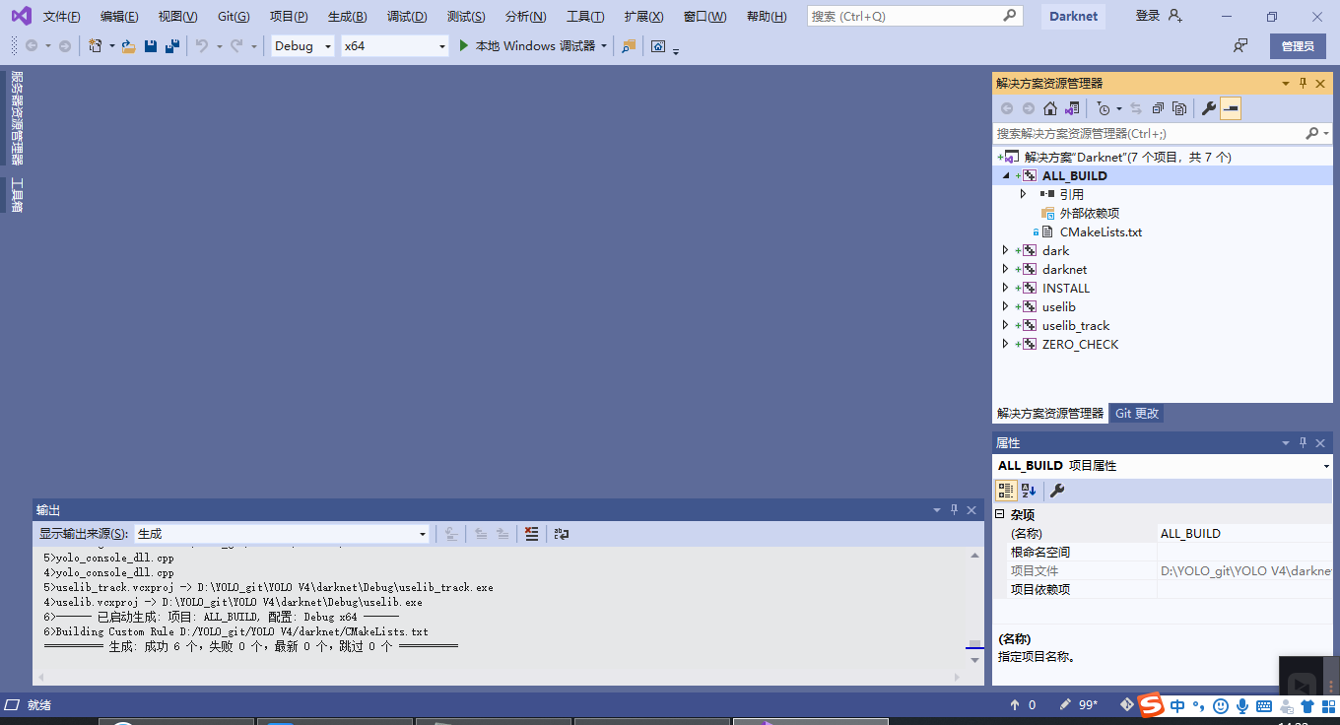

1. 再次查看，应该是生成错误了，生成的debug版本。重新将左上角版本换成Release x64.再次生成。（成功）

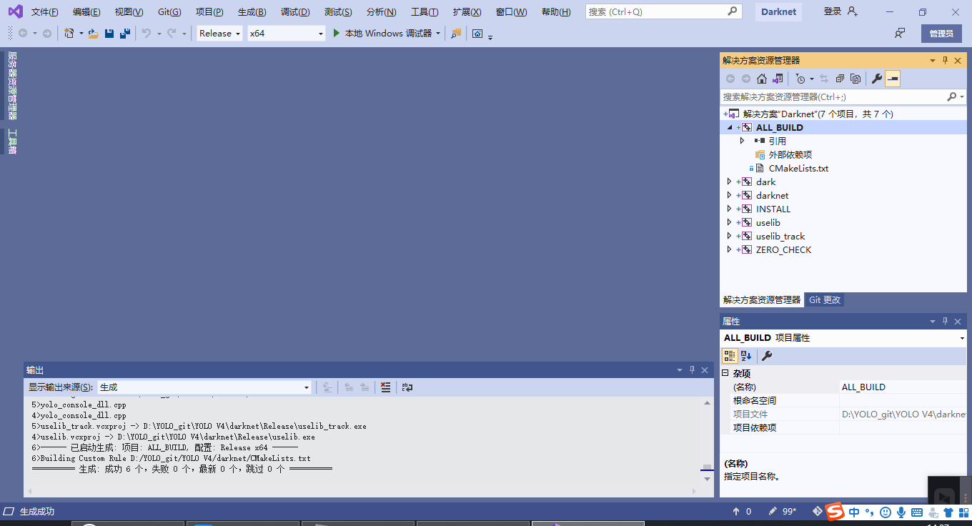

1. 编译完成之后，找到Release版本，复制darknet.exe

将D:\github\darknet\Release文件夹下的darknet.exe文件复制打开到D:\github\darknet\build\darknet\x64文件夹内进行粘贴，如下图所示

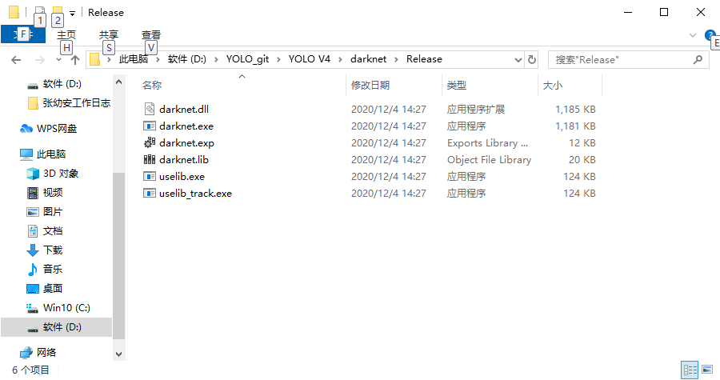

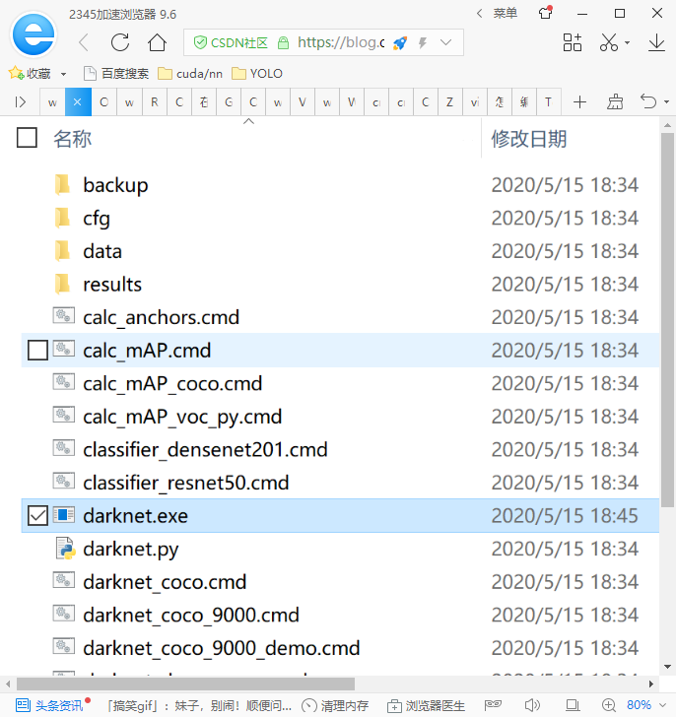

1. 将opencv …\opencv\build\x64\vc14\bin 下的两个opencv_world3412.dll和 opencv_ffmpeg3412_64.dll(具体参考opencv的版本，后缀相同就行)文件复制到上述文件夹内。如下图所示：

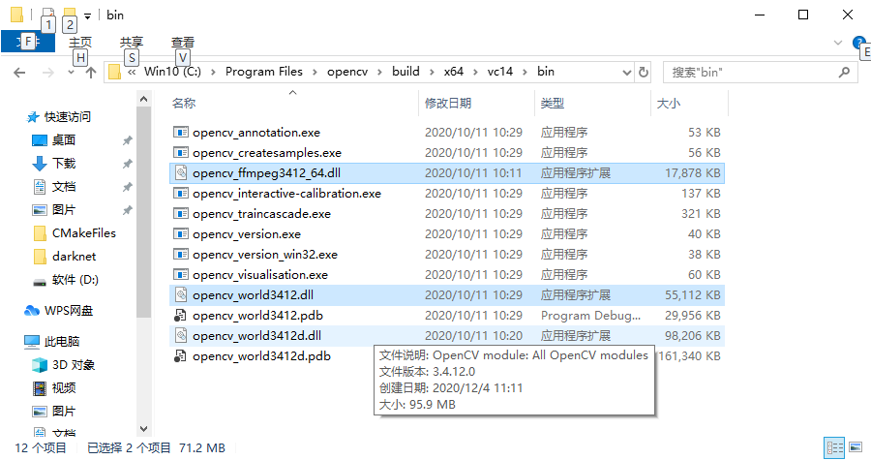

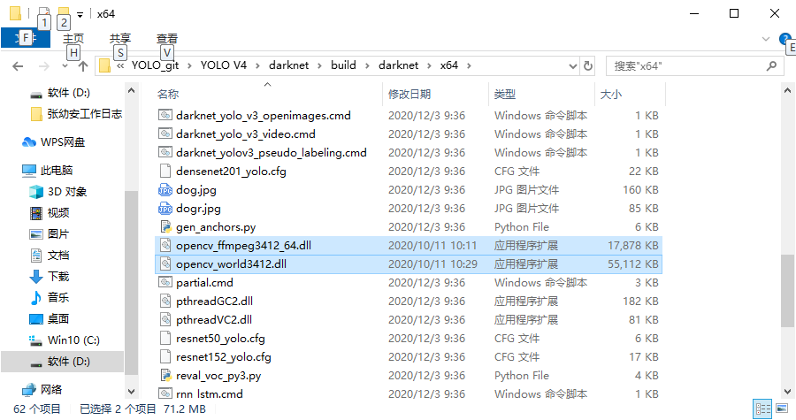

1. 将cuDNN中的cudnn64_8.dll（依据具体版本）复制到上述文件夹。

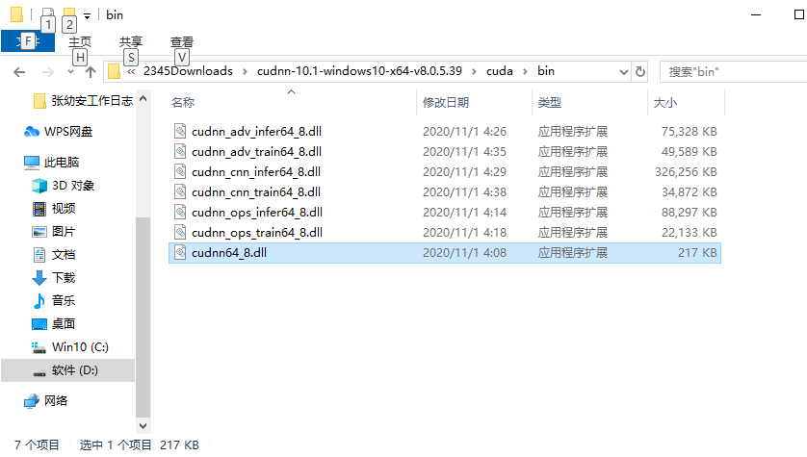

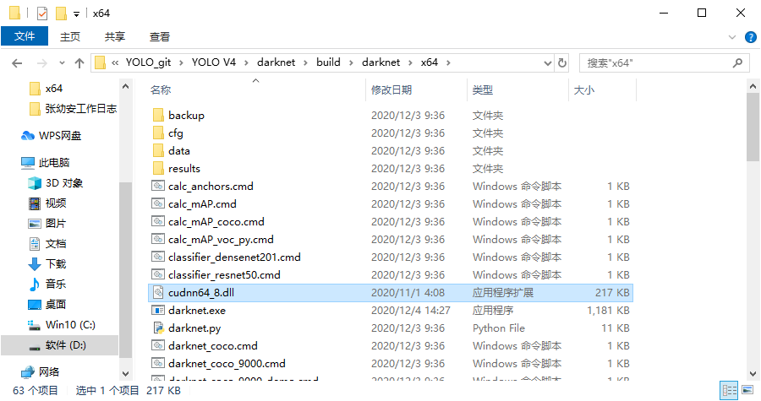

1. 下载vpn，提高github的下载速度。

**依旧无法下载！！！！！！！！！！！！！！**

1. 尝试直接将cuda添加到系统变量中的Path中。

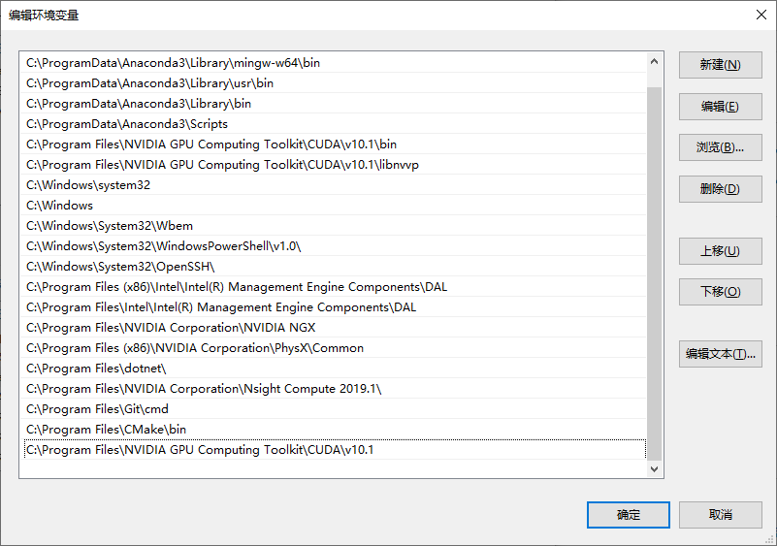

1. 并增加Opencv \bin路径在最后一条。

